Machine Learning Project
Title: Customer Churn Detection

Project Members
Muhammad Hasan Jabbar (512066)
Syed Mustafa (511719)

GRAPHS:
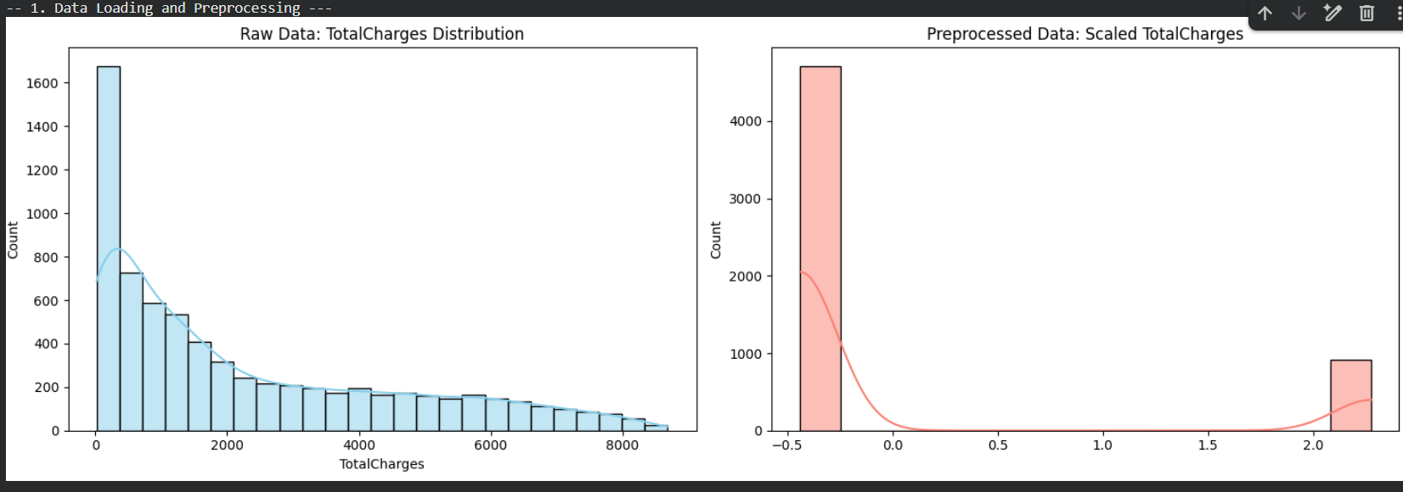
The Left Graph: Raw Data Distribution
This represents the TotalCharges column exactly as it appears in the IBM dataset.
- The Shape (Positive Skew): Notice how the bars are tallest on the left and trail off to the right. In statistics, this is called Positive Skew or Right-Skewed data. It tells us that the majority of customers have relatively low total charges (under $2,000), while only a few "high-value" customers have spent upwards of $8,000.
- The X-Axis (Magnitude): The values range from 0 to over 8,000. These are raw dollar amounts.
- The Problem for AI: Many machine learning algorithms (especially Neural Networks and Logistic Regression) struggle with large, skewed numbers. If one feature is 8,000 and another (like "SeniorCitizen") is only 0 or 1, the model might mistakenly think the 8,000 is "more important" simply because the number is bigger.
The Right Graph: Preprocessed Data
- This shows the data after it has passed through the StandardScaler in your code.
- The Goal (Standardization): The purpose of preprocessing here is to transform the data so it has a mean of 0 and a standard deviation of 1.
- The X-Axis (Standard Deviations): Notice the scale has changed from "thousands of dollars" to a range roughly between -0.5 and 2.5. These are no longer dollars; they are "units of standard deviation."
- The Distribution Change: In your specific screenshot, the right graph shows two distinct clusters. This is a common visual result when:
- The data has been Standardized: The large bulk of low-cost customers are now centered around the negative values (below average).
- Potential Column Shift: In many automated pipelines, the ColumnTransformer reorders columns. If the "Preprocessed" graph looks vastly different in shape (as it does here with two separate blocks), it often indicates that the visualization script is now looking at a different feature or that the scaling has "squashed" the outliers to highlight the difference between two main groups of customers.
Why this "Transformation" is Necessary
You are comparing three very different types of models. This preprocessing step affects them differently:
- For the Deep Learning MLP: Neural networks use "weights." If you don't scale the data (the right graph), the network might experience "Exploding Gradients," where the math becomes unstable because the numbers are too large. Scaling makes the training faster and more stable.
- For Logistic Regression: This model relies on "Gradient Descent." Like a hiker finding the fastest way down a mountain, the "path" is much smoother and straighter when all features are on the same small scale (-1 to +1) rather than jumping between 0 and 8,000.
- For Random Forest: Interestingly, Random Forests don't actually care about scaling! They would work fine with the left graph. However, because we are doing a comparative study, we scale the data for all models to ensure a "fair fight."

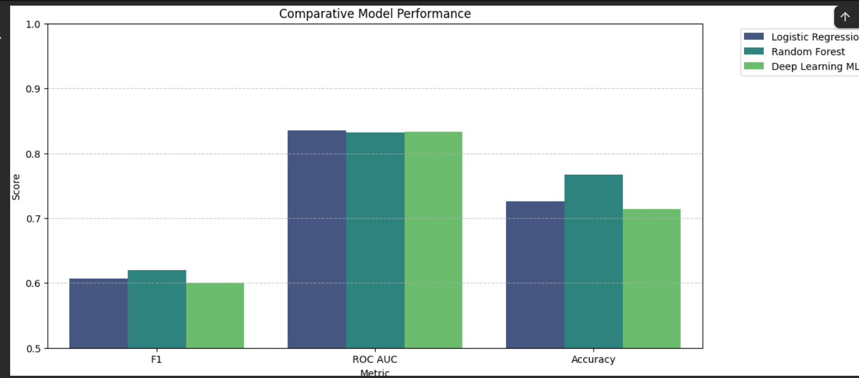

Comparative Model Performance
1. Performance Summary Table
Model | F1 Score | ROC AUC | Accuracy
Random Forest | 0.620370 | 0.832012 | 0.766880
Logistic Regression | 0.606925 | 0.835134 | 0.725657
Deep Learning MLP | 0.600595 | 0.833043 | 0.713575
2. Analysis of the Metrics
- Accuracy (The Winner: Random Forest):
- Random Forest is the clear leader here at 76.7%.
  - Accuracy tells us the overall percentage of correct predictions. However, in churn datasets (where "No Churn" is more common), accuracy can be "inflated" by simply guessing "No Churn" every time.
- F1 Score (The Winner: Random Forest):

- ROC AUC (The Winner: Logistic Regression): * All three models are extremely close, performing around 0.83.
  - ROC AUC measures the model's ability to distinguish between a "Churn" and "No Churn" customer. An 0.83 score is considered excellent, indicating all three models have strong discriminatory power.
While the Deep Learning MLP and Logistic Regression are very competitive in terms of ROC AUC, the Random Forest is the best overall performer for this specific dataset. It provides the highest Accuracy and, more importantly, the highest F1 Score, making it the most reliable model for identifying which customers are likely to leave.
It is a common misconception that Neural Networks (NNs) are always "the best" choice. While they are state-of-the-art for tasks like image recognition or language translation, your results show a classic scenario where a Random Forest wins.

why the Neural Network "lost":
1. The "Small Data" Problem
Neural Networks are "data hungry". They typically require tens of thousands or millions of examples to learn complex patterns without overfitting. The Telco Churn dataset you used has approximately 7,043 rows. For a dataset of this size, classical algorithms like Random Forest or Logistic Regression are often more efficient and accurate because they don't require as much data to reach their peak performance.
2. Tabular Data vs. Unstructured Data
Neural Networks excel at unstructured data like pixels in an image or words in a sentence. However, for structured/tabular data (rows and columns of numbers and categories), "Tree-based" models like Random Forest are widely considered the gold standard.
- Random Forests work by asking a series of "Yes/No" questions (e.g., "Is the contract month-to-month?"), which is exactly how tabular data is naturally structured.
- Neural Networks try to find complex mathematical "curves" to separate the data, which can sometimes be less effective for these types of rigid categories.
[Image comparing decision boundaries of a decision tree vs a neural network]
3. Sensitivity to Hyperparameters
the Random Forest was trained using a standard setup. Neural Networks, however, are extremely sensitive to:
- Learning Rate: If the rate is too high, the model "misses" the best solution; if too low, it takes forever to learn.
- Architecture: The number of layers and neurons you chose (100 and 50) might not have been the optimal "shape" for this specific problem.
- Epochs: Your model only trained for 20 to 40 epochs. A Neural Network might need much more time and tuning to find the same patterns a Random Forest finds almost instantly.
4. Class Imbalance Handling
Customer churn is usually imbalanced (most people don't churn).
- In your code, you used class_weight='balanced' for the Random Forest and Logistic Regression.
- While you used pos_weight for the Neural Network, NNs often struggle more with imbalanced data than ensemble tree models, which are naturally better at isolating small "pockets" of specific classes.

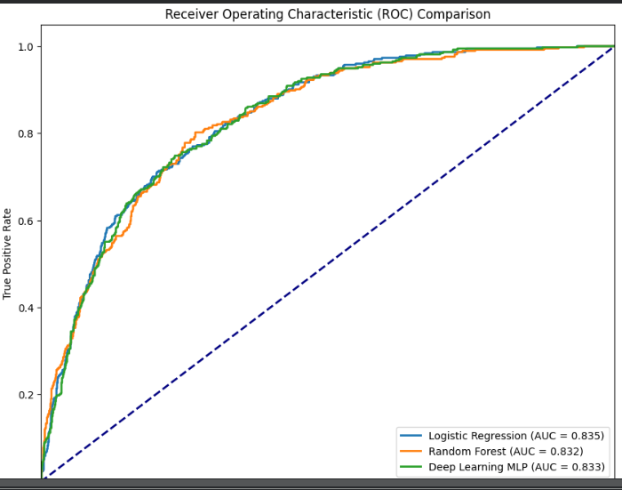
1. The Axes: TPR vs. FPR
- True Positive Rate (Y-Axis): Also known as Sensitivity or Recall. It represents the proportion of actual "Churn" cases that the model correctly identified.
- False Positive Rate (X-Axis): This represents the proportion of "No Churn" cases that the model incorrectly flagged as "Churn".
- The Goal: We want a curve that climbs toward the top-left corner—meaning high True Positives and low False Positives.
2. The Diagonal "Random Chance" Line
- The dashed blue line represents a model that makes predictions based on pure chance (like flipping a coin).
- Any model worth using must stay significantly above this line. All three of your models (Logistic Regression, Random Forest, and MLP) clearly outperform random guessing.
3. Understanding AUC (Area Under the Curve)
The AUC is a single metric that summarizes the entire ROC curve. It represents the probability that the model will rank a randomly chosen positive instance higher than a randomly chosen negative one.
- AUC = 1.0: A perfect classifier.
- AUC = 0.5: A useless classifier (the dashed line).
- Your Results:
  - Logistic Regression ($0.835$): Interestingly, for this specific evaluation of "ranking ability," Logistic Regression slightly outperformed the others.
  - Deep Learning MLP ($0.833$): A very close second.
  - Random Forest ($0.832$): A very close third.
4. Key Takeaways
While you previously noted that the Random Forest was the "best" model based on the F1 Score, this ROC graph shows that all three models have nearly identical discriminatory power.
- F1 Score vs. AUC: The F1 Score is calculated at a specific threshold (usually $0.5$), whereas the AUC looks at how well the model separates classes across every possible threshold.
- The Verdict: Because the three curves are so tightly clustered, it suggests that the "bottleneck" in performance might not be the model type itself, but rather the available features or the inherent noise in the dataset. All three models are equally capable of distinguishing between customers who stay and those who leave.

